vuanh

Tut 3

1. Matching

| 1. Supertype - d 2. entity cluster - f 3. subtype - a 4. specialization - e 5. discriminator - g 6. attribute - inheritance - c 7. overlap rule - b | a. ~~subset of supertype~~  b. entity belongs to two subtypes  c. ~~subtype gets supertype attributes~~  ~~d. generalized entity type~~  e. creating subtypes for an entity  type  ~~f. a group of associated entity types~~  ~~and relationships~~  ~~g. locates target subtype for an entity~~ |
| --- | --- |

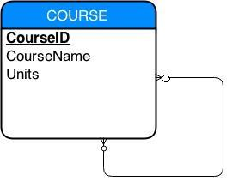

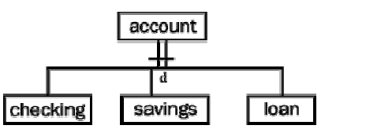

5.

1. 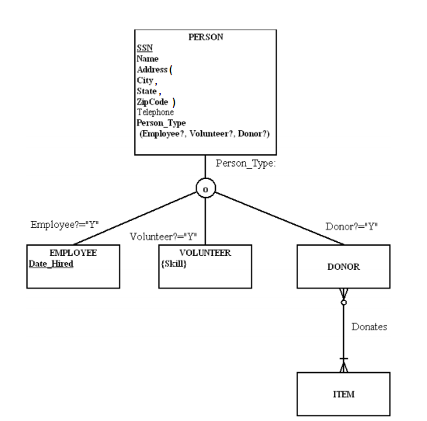

6.

a)

c)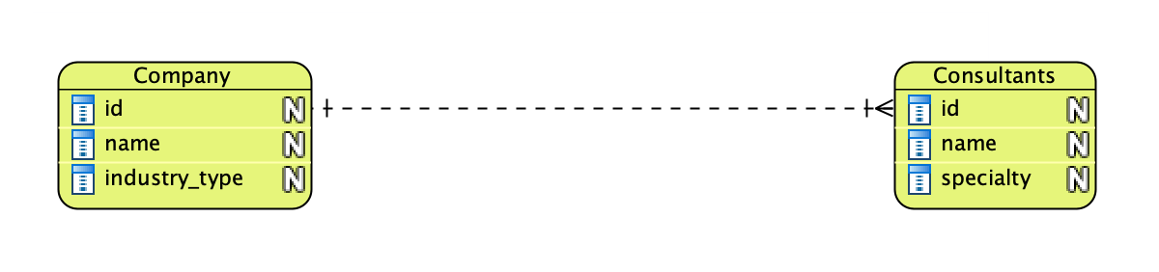

b) 